Please be advised that no application will be accepted after 4:30 PM on the scheduled filing date; refer to Form 108 for filing deadlines and meeting dates. No application will be considered as filed in an acceptable manner if any of the required application materials are inaccurate or incomplete, and such applications will be returned and will not be accepted for that month. If an applicant desires to amend his application, a completely new application may be required. No exceptions will be made. Please check with the planning staff if you have any questions regarding the application. Do this prior to the filing deadline if you expect to make corrections in time to file.

IMPORTANT: Legal counsel has advised that all information and exhibits regarding this application shall be attached to this application or presented to the Planning Commission at the public hearing. Direct individual contact with commissioners should not occur.

Zoning Map Amendment Procedures

1. Applicant secures necessary materials from the Planning Office -- this application form and any other necessary information.

2. Applicant submits complete and accurate application materials to the Planning Office, as summarized in the table at right.

3. Zoning Change Sign. The planning staff will place zoning change sign(s) on the property, visible from the road, 14 days before the scheduled public hearing, as required by state law. The sign(s) must remain in place until the public hearing occurs.

4. Staff Report. The planning staff will review the application and prepare a staff report including recommendations, conditions, and findings of fact. The report is forwarded to the OMPC, the applicant, and/or the applicant's attorney, one week before the scheduled OMPC public meeting.

5. Applicant responds by letter upon receipt of the staff report, if he desires to postpone or withdraw the application.

6. Legal Notice of Public Hearing will appear in the local newspaper at least seven (7) days before the public hearing. After publication, only OMPC action can permit postponement or withdrawal of the application. The Messenger-Inquirer will directly bill the applicant for the cost of advertising.

Application Materials to Submit
ITEMS | COPIES | PAGE
Enlarged USGS Topographic Map | 1 | 1
Transportation Plan | 1 | 2
Property Information Drawing | 20 | 2
Certified Letters with Postage | As needed | 5
Applicant Information | 1 for each Tract involved | 5
Filing Fee | 1 for each Tract involved | 5
Applicant & Owner Certifications | 1 for each Tract involved | 5
Legal Description of Property | 1 | 6
Location Status | 1 | 6
List of Adjoining Property Owners | 1 | 7
Applicant's Findings for Zone Change | 1 | 8

Enlarged USGS Topographic Map

An enlarged United States Geological Survey Topographic Map must be prepared and certified by a registered professional engineer, illustrating the following. Submit two (2) copies.

- Scale. Not less than 400 and not more than 660 feet to the inch. Show the date on which the map was prepared, north point, and the quadrangle name.
- Boundaries. Show the boundaries of the surface properties affected and the names of property owners. Also illustrate the names of all adjoining property owners.
- Area Affected. Identify actual ground area to be affected by the mining process.
- Features. Show the names and location of all streams, creeks or other bodies of water, roads, buildings, cemeteries, oil and gas wells, and utility lines on the area of land affected and within 500 feet of such area.
- Haul Road. Show the proposed haul road from the affected area to a public-maintained right-of-way.
- Drainage. Illustrate proposed silt basin locations and drainage off the affected properties.

7. Public Hearing will be held by the OMPC generally on the second Thursday of each month at Owensboro City Hall. After hearing all comments, the OMPC will either act to permit withdrawal, postpone action, or recommend approval or disapproval to the appropriate legislative body.

8. OMPC's Recommendation and Findings are sent to the legislative body after the court reporter has returned the transcribed minutes of the public hearing at which the OMPC takes final action.

9. Legislative Body, after receiving the recommendation and findings of the OMPC, will review the records, schedule two readings, and take action if the Legislative Body or any aggrieved person files a request for the map amendment to be decided by the legislative body, within 21 days of OMPC action. If no request is filed, the OMPC recommendation becomes final 21 days after the recommendation is made. At the second reading, the legislative body may permit the applicant's attorney or others to make statements pertinent to the record. The legislative action becomes effective with legal publication in the local newspaper or legislative body final action, whichever occurs last.

Transportation Plan
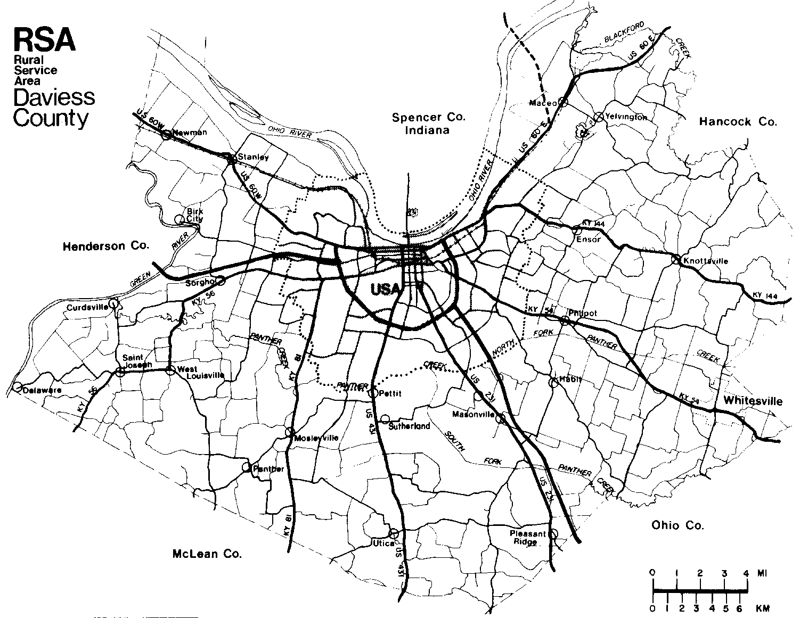
Submit two (2) copies of a Transportation Plan. The plan shall set forth the portions of the State Primary, State Secondary, Rural Secondary, and County Roads over which the applicant proposes to transport materials extracted in the mining operations.

- Distinguish the different classifications of roads.

- Specify the legal weight limits for each portion of the transportation route (including bridges) over which the applicant proposes to transport minerals. Include any proposal to obtain a special permit to exceed established weight limits on any highway or bridge.

- Include a certification by a duly authorized official of the Dept. of Transportation attesting to the accuracy of the transportation plan in regard to the location and identities of highways and bridges of the state-maintained system; likewise, from the County Engineer, for the county-maintained system.

Property Information Drawing

Submit twenty (20) copies of the drawing illustrated in the sample at right.

Must be prepared by registered civil engineer or registered land surveyor. Maximum page size: 8½" x 11" unless larger size is necessary for clarity.

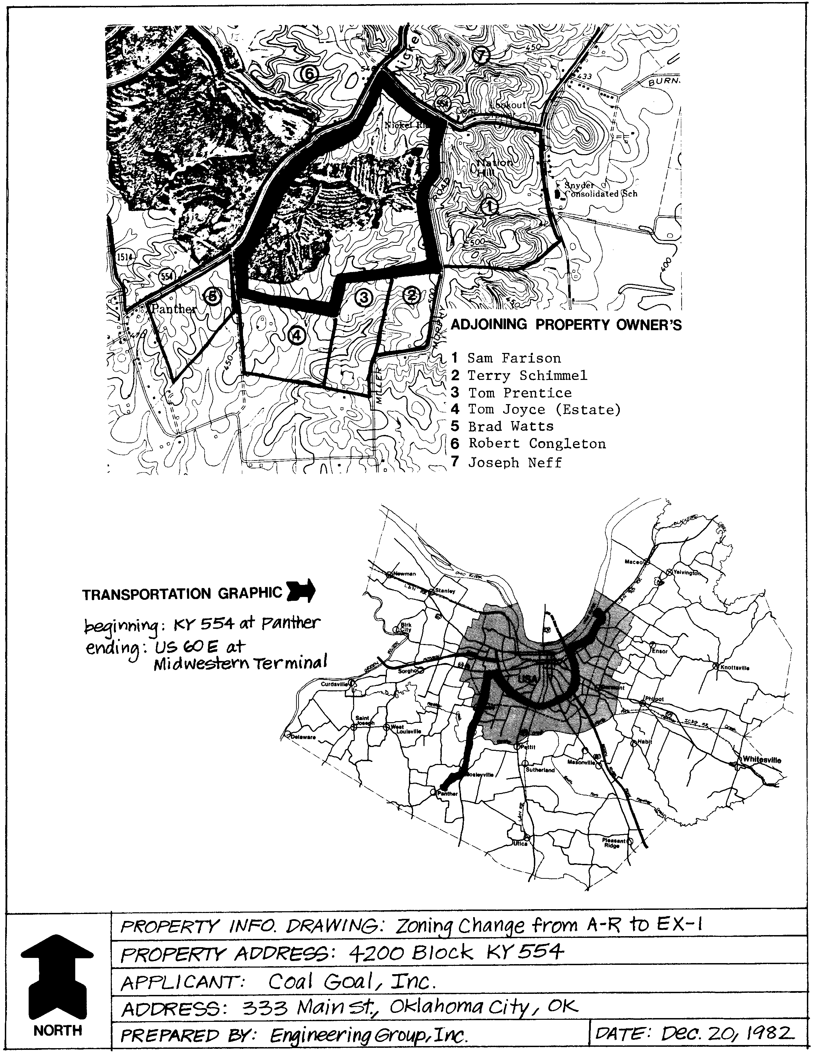
REQUIRED CONTENTS:

- Property Area Map drawn on a USGS 7.5-minute quadrangle topographic map, showing the boundaries of the subject property, the boundaries of the surface properties to be affected, and the names of owners of all properties adjoining the subject property, including those across roads and other public rights-of-way.

- Transportation Graphic showing the route from the subject property to its final destination, which may be prepared using the blank map of Daviess County provided above.

- Title Box showing the information in the sample at right.

- Orient north to the top of the drawing.

Certified Letters with Postage

The applicant is required to prepare letters and address envelopes to be sent to the owner(s) of each property adjoining the subject property, including properties directly across streets and other public rights-of-way. The letters will notify adjoining property owners of the applicant's request for a zoning map amendment as well as the date, time and place of the public hearing regarding the application. Adjoining property owners' names and mailing addresses are included on the Property Information Drawing, Page 2, and in the List of Adjoining Property Owners on Page 7.

All letters must be typewritten and are submitted with the filing of the application. On Page 4 is a form letter that should be used. Fill in all blank lines EXCEPT for the addressee's name and address (at top left of the letter). When filling in Item #3 on the letter, use full zone name and description as shown in the table on Page 5. Then photocopy the number of letters needed. Finally, fill in the name and address on each letter for each adjoining property owner to be notified. The OMPC Director will sign the letters after the application is submitted.

Use plain envelopes, addressed to each adjoining property owner. Make certain to put the OMPC's return address in the upper left-hand corner of each envelope!

Owensboro Metropolitan Planning Commission
Post Office Box 732
Owensboro, KY 42302-0732

DO NOT seal envelopes. Instead, leave them open for planning staff to check. Place the appropriate letter inside each envelope.

Complete Certified Mail as follows:

1 Complete receipt for certified mail for each envelope as shown at right. DO NOT affix to envelope.

2 Affix *TOTAL in postage stamps on upper right hand front of each envelope. DO NOT use postage meters. NO CHECKS to postmaster for certified mail. See table at lower right for current postal rates.

3 Paper-clip each completed receipt and card to the appropriate envelope. Submit the UNSEALED letters with the other application materials.

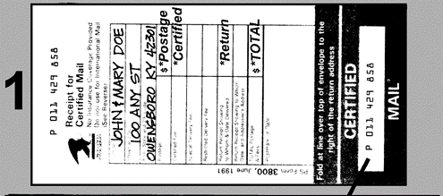
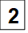
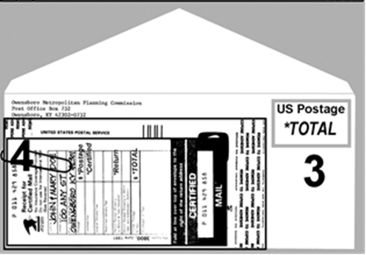

Current Postal Rates
*Postage 1st ounce | $0.78
*Certified Mail | $5.30
*TOTAL | $6.08

TO: | Application  Filing Date:
This letter is being sent to inform you that the owner of property adjoining yours has requested the Owensboro Metropolitan Planning Commission to hold a public hearing on changing the zoning classification of his property. While the date for the public hearing has been set (see #9 below), an occasional withdrawal or requested postponement may occur. If this happens, the planning staff will make every effort to contact the adjoining property owners. The recommendation of the Owensboro Metropolitan Planning Commission will automatically become effective 21 days after action unless the appropriate legislative body or an aggrieved person files written notice to the OMPC requesting the application to be decided by the appropriate legislative body. Request forms for legislative body to decide zoning change are available in the OMPC office.
1. Address of property requested for zone change...........
2. Acreage involved..........................................................
3. Zone change requested................................................ | From:
 | To: EX-1 Coal Mining
4. Owner/Co-Applicant of property for zone change.........
5. Address of Owner/Co-Applicant....................................
6. Name of zone change Applicant...................................
7. Zone Change Applicant is using the following attorney..
8. Address & telephone of… | Address:
❑ Applicant  Applicant's attorney....
 | Phone:
9. Tentative date of public hearing meeting........................
10. Time and place of meeting............................................ | 5:30 PM, 4th Floor Auditorium  Owensboro City Hall, 101 East 4th Street  Owensboro, KY
If you should desire any additional information about this zone change request, please feel free to contact me or any other member of the planning staff at the OMPC offices, or call 270-687-8650. A staff report and recommendation will be available the Monday before the Thursday hearing. Legal counsel has advised that all information and exhibits regarding this application shall be attached to this application or presented to the commission at the public hearing. Direct individual contact with the commissioners should not occur.
Enclosure: Summary of Zoning Change Process | Respectfully,
 | Brian R. Howard, AICP, OMPC Director

Applicant Information
In filling out this form, please note that the term Owner / Co-Applicant is used to denote that each owner of surface tracts and coal rights constituting the subject property is considered to be a party to this application and that each owner has authorized its submission, even when the primary applicant is not the current legal owner.

Submit two (2) copies of this completed page for each tract constituting the subject property. Include Attorney and Filing Fee information ONLY on the sheet containing information/signatures for Tract 1.

Date received by Planning Office

Tract Number for Zone Change
Acreage of
this Tract

Total Acreage of
All Tracts in Application

Street
Address
of this Tract

Existing
Zoning

Existing Land Use
(Be specific)

Applicant
Name

Address

Day Telephone

Applicant’s Attorney if applicable
Name

Day Telephone

Owner / Co-Applicant of Surface Tract
Name

Address

Day Telephone

Owner / Co-Applicant of Coal Rights
Name

Address

Day Telephone

Filing Fee
ZONING CHANGE FROM…
A-R Rural Agriculture | P-1 Professional/Service
A-U Urban Agriculture | B-1 Neighborhood Bus. Center
MHP Manuf. Housing Park | B-2 Central Business
R-1A Single-Family Residential | B-3 Highway Business Center
R-1B Single-Family Residential | B-4 General Business
R-1C Single-Family Residential | I-1 Light Industrial
R-1T Townhouse | I-2 Heavy Industrial
R-2MF Multi-Family Residential
R-3MF Multi-Family Residential | FILING FEE AMOUNT  $246 + $5 / whole acre
R-4DT Inner-City Residential | FILING FEE AMOUNT  $246 + $5 / whole acre
NUMBER OF WHOLE ACRES
FILING FEE | $

Applicant & Owner Certifications
By the Applicant: I do hereby certify that, to the best of my knowledge and belief, all application materials are herewith submitted, and the information they contain is true and correct. I further certify that I accept responsibility for payment of advertising costs relating to this application and fully understand that the Messenger-Inquirer requires that the OMPC Hearing Notice be paid in full before the notice is published. If the applicant fails to pay for the notice when contacted by the Messenger-Inquirer the item cannot be heard by the OMPC.
PLEASE TYPE OR PRINT

Applicant's Signature Date

By the Owner/Co-Applicant of Surface Tract: I do hereby certify that I am the owner of this surface tract and authorize the submission of this application.

Surface Tract Owner’s Signature Date

By the Owner/Co-Applicant of Coal Rights: I do hereby certify that I am the owner of coal rights for this tract and authorize the submission of this application.

Coal Rights Owner’s Signature Date

SUBSCRIBED AND SWORN TO, before me, by

______________________________________________

______________________________________________

On this the _______ day of _______________, ________.

My commission expires ___________________________

Notary Public __________________________________

Legal Description of Property
Submit two (2) copies. A legal description of the subject property must accompany submitted application materials.

Location Status
Submit two (2) copies of this completed page. In this part of the application, the applicant must address the status of development patterns and the environment at the location of the subject property.
PLEASE TYPE OR PRINT

Development Patterns Status

surrounding the subject property:

North

Existing
Zoning _________________________

Existing Land
Use (be specific) ________________________________

East

Existing
Zoning ___________________________

Existing Land
Use (be specific) ________________________________

South

Existing
Zoning _________________________

Existing Land
Use (be specific) ________________________________

West

Existing
Zoning __________________________

Existing Land
Use (be specific) ________________________________

Environmental Status

of the subject property:

Floodplain Areas  Yes  No If Yes:

Flood Insurance Rate Map Zone ________________

Base Flood Elevation (100-Year) ________________

Floodway Areas  Yes  No

Known Wetlands Area  Yes  No

Soils. Identify soil types and agricultural potential.

SOIL  TYPE | AGRICULTURAL POTENTIAL

Name of Coal Bed _____________________________

Depth of Coal (range) ___________________________

Coal Seam Thickness (range) ___________________

Prime Agricultural Land (% of total acreage) _______ %

Steep Slopes (greater than 16% grade)  Yes  No

Known Historical, Archaeological Sites  Yes  No

List of Adjoining Property Owners

Submit two (2) copies of the completed list below.

The applicant must submit a list of names and mailing addresses of all persons owning property adjoining the subject property, including properties directly across streets and other public right-of-way. Use the form below. The names shall be secured from the records of the Daviess County Property Valuation Administrator (PVA) no more than thirty (30) days prior to submission of this application, and shall be referenced by street address to the street addresses on the Property Information Drawing submitted as part of this application.

In cases where a business, institution or other owner group is to be notified, please provide the name of the president, chairman or other officer of the owner group. The applicant should retain a copy of this listing, especially to ensure that certified letters notify all adjoining property owners.

Address of Property  Adjoining Subject Property | Name(s) of  Property Owner(s) | Mailing Address(es)  with Zip Codes

PLEASE TYPE OR PRINT

Applicant's Findings for Zone Change

Submit two (2) copies of the completed findings below.

In order for the Owensboro Metropolitan Planning Commission to make a recommendation for a zoning map amendment, it must make findings of fact in support of its recommendation. The type of facts that must be cited in support of the applicant's proposal depends on whether or not the proposal is found to be in compliance with the criteria of the adopted comprehensive plan. Below, the applicant must address either Type 1 Findings or Type 2 Findings.

Type 1 Findings - IN COMPLIANCE: If the applicant determines that his/her proposal is in compliance with the Comprehensive Plan, the applicant must cite specific facts with reference to the Land Use Criteria and/or other elements of the Comprehensive Plan in support of this determination.

Type 2 Findings - NOT IN COMPLIANCE: If the applicant determines that his/her proposal is NOT in compliance with the Comprehensive Plan, the applicant must state specific facts in support of one or both of the following:

A. The existing zoning classification given to the property is inappropriate and the proposed zoning classification is appropriate; AND/OR

B. There have been major changes of an economic, physical or social nature within the AREA involved which were not anticipated in the adopted comprehensive plan and those changes have substantially altered the basic character of the AREA involved.

Below, the applicant must address either Type 1 or Type 2 Findings in support of the Zone Change, and submit two (2) copies. The types of findings are described above. Attach additional sheets if more space is needed.

PLEASE TYPE OR PRINT

